Explanatory Rubric
Name: |  | Title: | Forth of July
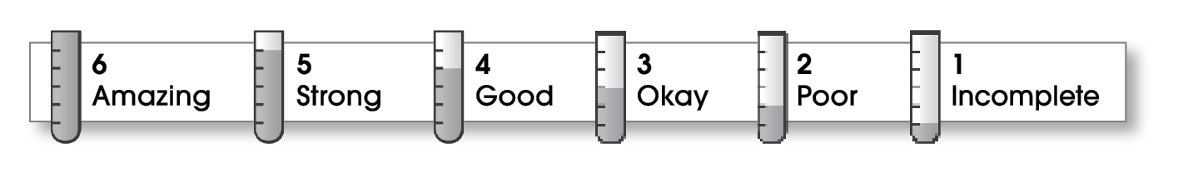

2 | Structure
- The writing has a beginning, a middle, and an ending.
- The details follow a clear order.
2 | Ideas
- The writing has an interesting topic.
- Details make the topic clear.
- Sentences are easy to read.
- The writing uses specific words.
1 | Correctness
- A capital letter begins each sentence and name.
- Sentences end with correct punctuation.
- Common words have correct spelling.

Comments: I like your description of the big blue fireworks, but your writing needs a lot more details like this. You also need to add an ending that relates back to your topic. Reading your writing out loud might help you spot errors. You might also ask a partner to check your writing for errors.

© Thoughtful Learning For Write Away

